Week 2 Maths
Session 1- counting in 2s
Verbally ask your children to count in 2’s (as high as they can- they usually get to about 30).
Then using a 100 square can the children colour in the 2 times table up to 100. Do they notice a pattern?
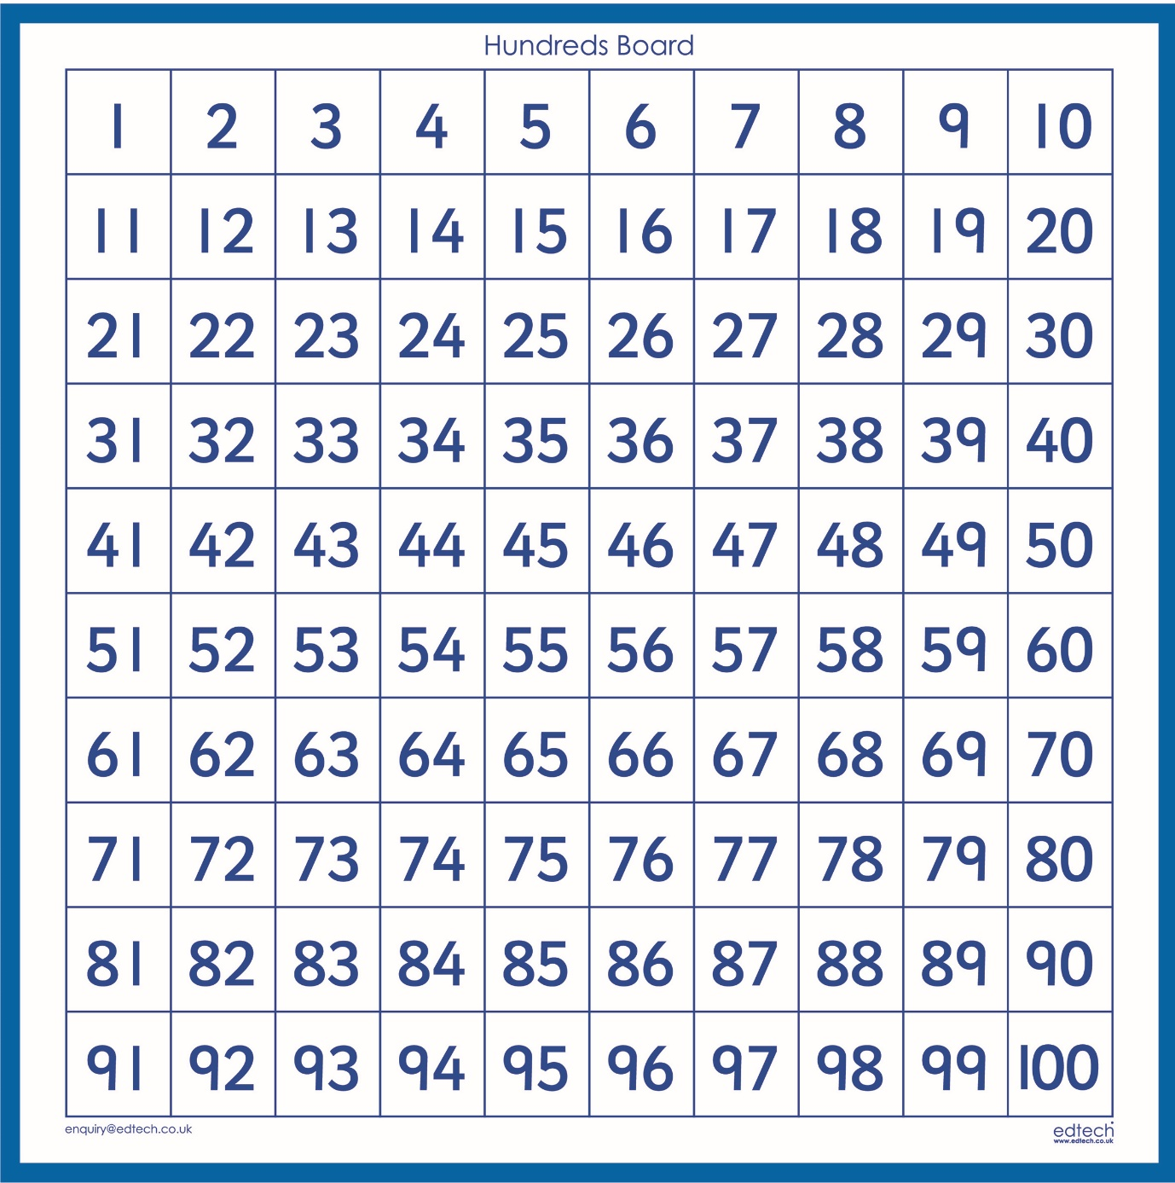
Now can the children finish these patterns by counting 2s;
2 | 4 | 6 | 8 | _____ | ______ | ______ | ______ | ______ | ______

18 | 16 | 14 | _____ | ______ | ______ | ______ | ______ | ______ | ______

5 | 7 | 9 | _____ | ______ | ______ | ______ | ______ | ______ | ______
Session 2- counting in 5s
Verbally ask your children to count in 5’s (as high as they can- they usually get to 100).
Then using a 100 square can the children colour in the 5 times table up to 100. Do they notice a pattern?
Now can the children finish these patterns by counting 5s;
5 | 10 | 15 | _____ | _____ | ______ | ______ | ______ | ______ | ______

40 | 45 | 50 | _____ | ______ | ______ | ______ | ______ | ______ | ______

80 | 75 | 70 | _____ | ______ | ______ | ______ | ______ | ______ | ______

Session 3- counting in 10s
Verbally ask your children to count in 10’s (they usually get to 100 and back to 0).
Then using a 100 square can the children colour in the 10 times table up to 100. Do they notice a pattern?
Now can the children finish these patterns by counting 10s;
10 | 20 | 30 | _____ | _____ | ______ | ______ | ______ | ______ | ______

90 | 80 | 70 | _____ | ______ | ______ | ______ | ______ | ______ | ______

80 | 90 | 100 | _____ | ______ | ______ | ______ | ______ | ______ | ______

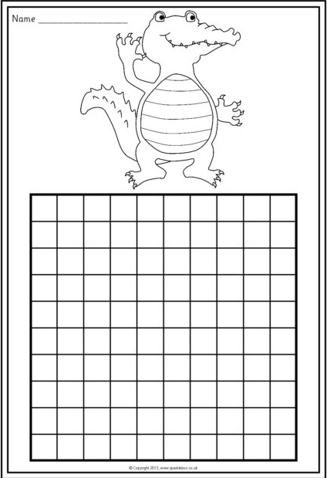
Bonus session- can your child fill in this blank number square.

