Year 2 History w/c 11.05
Who was Florence Nightingale?

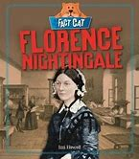

Watch the video about her
https://www.bbc.co.uk/bitesize/topics/zns9nrd/articles/znsct39
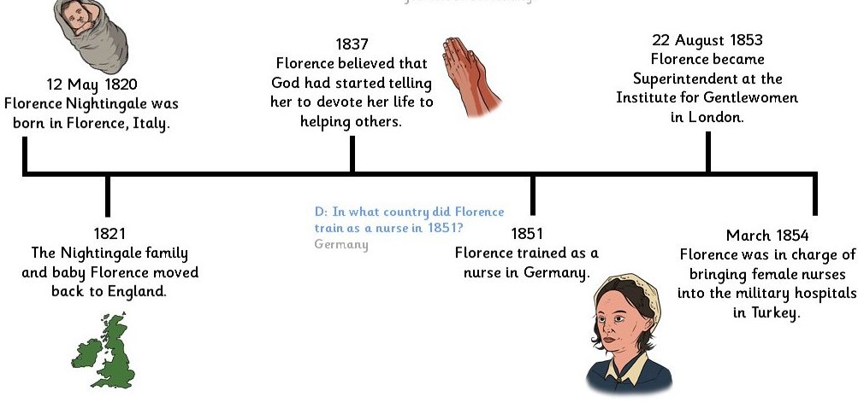
Listen to the story
https://www.bbc.co.uk/teach/class-clips-video/true-stories-florence-nightingale/z68fcqt

