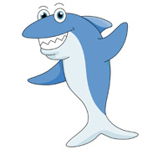
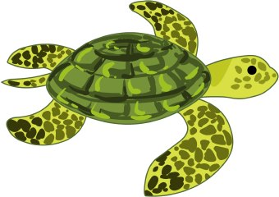 Week 2 Topic

- DT- We hope you enjoyed making your vehicle using cardboard boxes etc. If you haven’t done it yet then please do so. Remember your child did a plan at school of what they wanted to make so try to stick to the plan. Once painted please take a picture and then write an evaluation of it. What went well? What was tricky? Would you change anything next time?
- Art/RE- to make an Easter card for your parents or grandparents- maybe you could post it to them.
- Science/Forest Schools- watch this clip all about Spring https://www.youtube.com/watch?v=vLAnt9__5Mg then children to make a Spring picture outside using natural materials- take a photo of it once it is done.
- PE- Yoga- https://www.youtube.com/user/CosmicKidsYoga
PE with Joe- https://www.youtube.com/watch?v=Rz0go1pTda8
Real PE- The website address is: home.jasmineactive.com
Parent email: parent@heatherrid-1.com
Password: heatherrid
- Music- Charanga- you should have the logins already for this.
- Easter activity idea https://www.youtube.com/watch?v=whhsRrZfWXM

