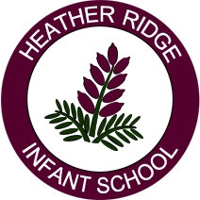

Packed Lunches
Heather Ridge Infant School is a Healthy School which means we promote healthy eating in both our school dinners and packed lunches.

A child at school should have about a third of their daily nutrient requirements at lunchtime. This means they need food that are going to provide them with enough energy, protein, fibre, vitamins and minerals.

A healthy packed lunch should contain a mix of foods from the Eat Well Plate. The Eat Well Plate shows how much should be eaten from each of the five food groups.

A good packed lunch contains:

- A starchy food, such as bread, rolls, pitta bread, naan bread, potatoes, rice, noodles. These foods are good for children to fill up on.

- A good source of protein, iron and zinc such as meat, fish, beans, nuts or eggs.

- A good source of calcium such as milk, cheese, yoghurt or fromage frais.

- And one portion of fruit and one portion of vegetable or salad to provide all the other vitamins and minerals. A piece of fruit could be a 100% juice or piece of fresh fruit, dried fruit or tinned fruit in fruit juice. A piece of vegetable could be a fresh vegetable such as carrot stick, salad or a vegetable soup or vegetable dish.

No single food contains all the essential nutrients the body needs to be healthy and function efficiently so it is important that the content of the packed lunch is varied.

You can find lots of ideas for tasty and easy to prepare lunchbox foods at www.nhs.uk/Change4Life/Pages/healthy-lunchbox-picnic.asp

