19th March 2020
Key Workers’ children following further guidance

Dear Parents/ carers,

Following on from previous correspondence, I write to confirm categories of jobs that fall into the definition of ‘key workers’ as follows:

- The National Health Service
- The Armed Forces
- Teachers, school staff and childcare staff
- Care home workers
- Social workers
- Pharmacists
- Police officers, community support officers and civilian staff working for the police
- Prison officers and other probation staff
- Firefighters
- Local Authority Officers directly engaged in contingency planning for COVID-19
- Environmental Health officers
- Highway Agency traffic officers
- Supermarket staff and supermarket delivery drivers
- Employees of key infrastructure industries such as gas/electricity

Please note: the guidance also states that if a child has more than one parent/carer, and they reside in the same house as the child, BOTH parents must be classed as key workers in order to qualify for childcare/ education in school.

Following the guidance please email us to keyworker@heather-ridge.co.uk before midday tomorrow (Friday 20th):
- your child’s name
- their class
- parent(s) job title
- whether your child would be at school every day or only on certain days.

We also require proof of your occupations to be brought to the school office, as soon as possible.

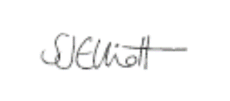
Kind regards,

Miss Sarah Elliott
Head Teacher

