Week 2 Maths
Session 3- counting in 10s
Verbally ask your children to count in 10’s (they usually get to 100 and back to 0).
Then using a 100 square can the children colour in the 10 times table up to 100. Do they notice a pattern?
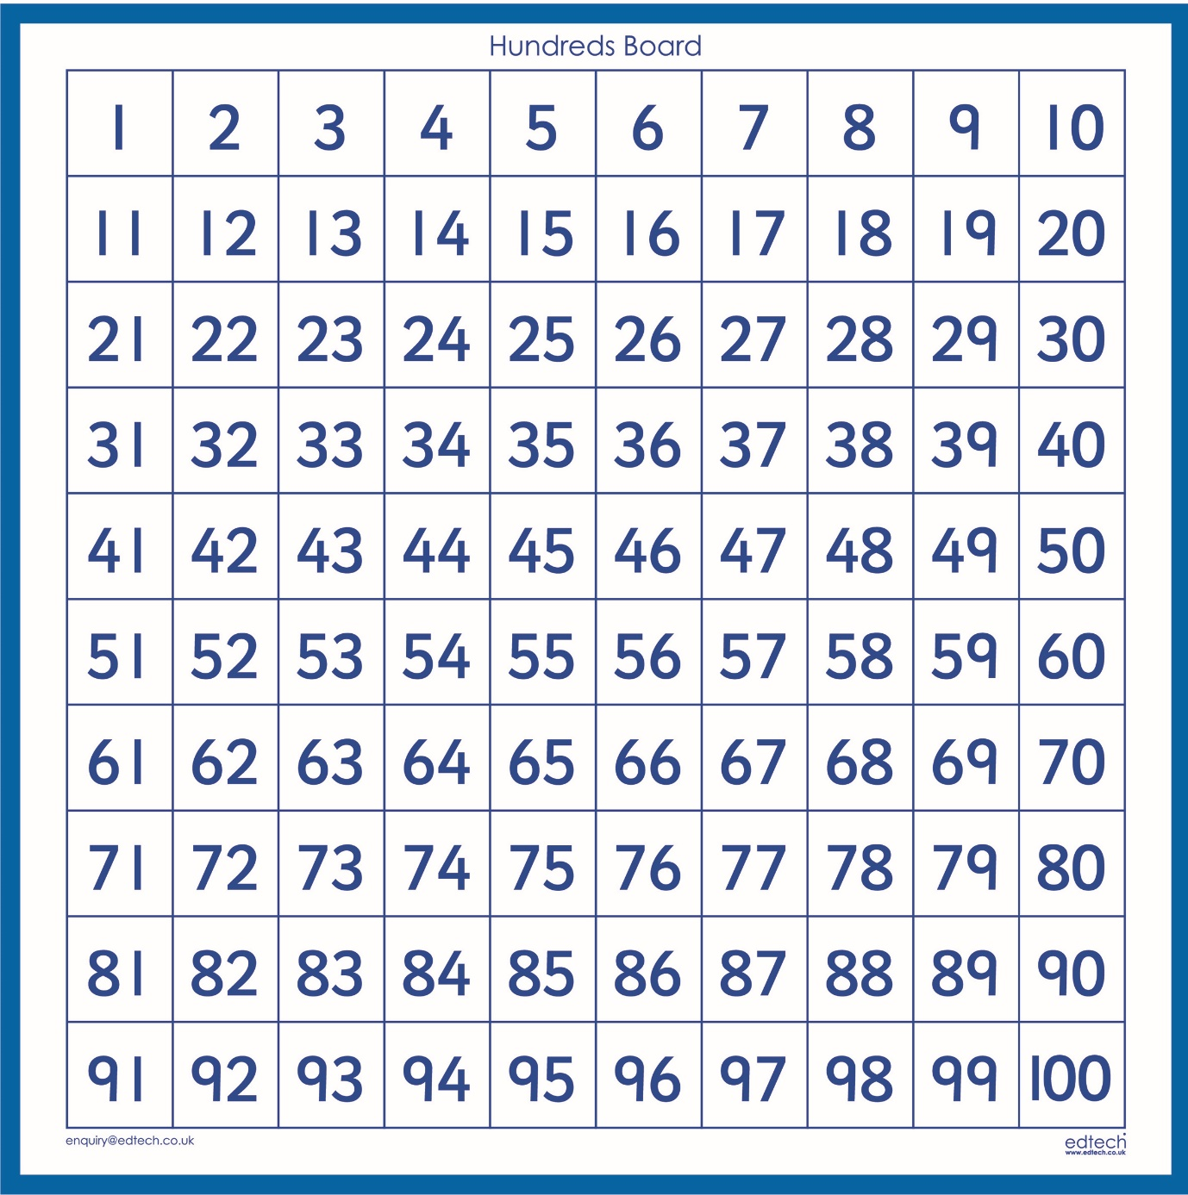
Now can the children finish these patterns by counting 10s;
10 | 20 | 30 | _____ | _____ | ______ | ______ | ______ | ______ | ______

90 | 80 | 70 | _____ | ______ | ______ | ______ | ______ | ______ | ______

80 | 90 | 100 | _____ | ______ | ______ | ______ | ______ | ______ | ______

