Funny bunny!
Can you label the bunny using describing words?
Words to help you

rabbit basket Easter

long funny round
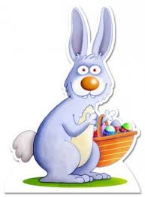

Can you give your bunny a name?
Challenge: can you write a short story about the Easter bunny?

