Land of the dinosaurs
Can you write one or more sentences about the following picture?
Words to help you

dinosaurs pterodactyl t-rex

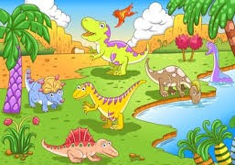

Challenge: Draw your own dinosaur and describe it. What does it look like? What does it eat? Where does it live?
My dinosaur

